**SC2006 Software Engineering**



**Lab#2 Deliverables**

Lab Group FDAD

Group Name: InternLink

| Group Members | |
| --- | --- |
| Name | Matriculation No. |
| Ewen Cheung Yi Wen | U2423907E |
| Gerald Chan Weiheng | U2421492H |
| Chai Zheng wen | U2421555H |
| Jusvin Adrian Tan | U2421479D |
| Saw Yong Xuen | U2420203J |
|  |  |

InternLink - Use Case Description

Frequency Level : 1-Lowest, 2-Low, 3-Normal, 4-High, 5-Highest

Priority Level : 1-Lowest, 2-Low, 3-Normal, 4-High, 5-Highest

| Use Case ID: | USER_UC_1 | | |
| --- | --- | --- | --- |
| Use Case Name: | Choose Role: Job Seeker or Employer | | |
| Created By: | Ewen Cheung | Last Updated By: | Ewen Cheung |
| Date Created: | 19 Feb 2025 | Date Last Updated: | 20 Feb 2025 |

| Actor: | User |
| --- | --- |
| Description: | When users access the website, they are prompted to choose whether they want to continue as a Job Seeker or an Employer. Their selection determines which authentication page (Sign-In or Sign-Up) they are redirected to. |
| Preconditions: | 1. The user has accessed the website. 2. The user is not yet authenticated. |
| Postconditions: | 1. The user is redirected to the appropriate authentication page (Job Seeker or Employer). |
| Priority: | 5 |
| Frequency of Use: | 5 |
| Flow of Events: | 1. The user accesses the website. 2. The system displays a selection screen with options: "Continue as Job Seeker" or "Continue as Employer." 3. The user selects one of the two options. 4. The system redirects the user to the appropriate authentication page (Sign-In/Sign-Up). |
| Alternative Flows: | AF-1a: User selects the wrong option   1. The system provides a back button or a toggle to allow the user to switch roles. |
| Exceptions: | E-1: System fails to load the selection page   1. The system displays an error message and prompts the user to retry. |
| Includes: | User authentication (Sign-Up or Sign-In). |
| Extends: | Role selection persistence (system remembers the last selected role for returning users). |
| Special Requirements: | The selection page should be responsive and load quickly. |
| Assumptions: | Users have a stable internet connection. |
| Notes and Issues: | Consider adding a "Remember my selection" option for returning users. |

| Use Case ID: | USER_UC_2 | | |
| --- | --- | --- | --- |
| Use Case Name: | Messages | | |
| Created By: | Ewen Cheung | Last Updated By: | Ewen Cheung |
| Date Created: | 19 Feb 2025 | Date Last Updated: | 20 Feb 2025 |

| Actor: | User |
| --- | --- |
| Description: | Users can communicate via an in-app messaging system. Messages can only be sent under specific conditions to prevent spam. |
| Preconditions: | 1. The user is logged into their account. 2. The user navigates to the "Messages" section. |
| Postconditions: | 1. A message is successfully sent or saved as a draft. 2. The recipient receives a notification of a new message. |
| Priority: | 3 |
| Frequency of Use: | 4 |
| Flow of Events: | 1. The user clicks the "Messages" button in the navigation bar. 2. The system displays a list of recent conversations and a search bar to find contacts. 3. The user selects a recipient. 4. The user types a message in the chat box. 5. The user clicks "Send." 6. The system delivers the message and notifies the recipient. |
| Alternative Flows: |  |
| Exceptions: | E-1: Message fails to send   1. The system displays an error message and allows the user to retry. |
| Includes: | Message validation and spam protection. |
| Extends: | 1. Read receipts (to track when messages are read). 2. Draft messages (If the user loses internet connection before sending, the message is saved as a draft). 3. Restricting messages after three attempts (If the recipient has not responded to the last three messages, the sender is restricted from sending additional messages until a reply is received). 4. Blocking users (If blocking is implemented, users will not be able to send messages to blocked contacts). 5. Reporting messages (Allowing users to report inappropriate messages for admin review). |
| Special Requirements: | The system should provide a smooth and responsive chat experience. |
| Assumptions: | Users are aware of the messaging restrictions. |
| Notes and Issues: | Consider implementing an admin review for reported messages in future versions. |

| Use Case ID: | USER_UC_3 | | |
| --- | --- | --- | --- |
| Use Case Name: | Settings | | |
| Created By: | Ewen Cheung | Last Updated By: | Ewen Cheung |
| Date Created: | 19 Feb 2025 | Date Last Updated: | 20 Feb 2025 |

| Actor: | User |
| --- | --- |
| Description: | The settings page allows users to adjust preferences and log out. |
| Preconditions: | 1. The user is logged into their account. |
| Postconditions: | 1. The user successfully logs out and is redirected to the role selection page. |
| Priority: | 2 |
| Frequency of Use: | 4 |
| Flow of Events: | 1. The user clicks the "Settings" button. 2. The system displays a dropdown menu with available options. 3. The user selects "Log Out." 4. The system logs the user out and redirects them to the role selection page. |
| Alternative Flows: | AF-3a: User cancels logout   1. The settings menu closes with no action taken. |
| Exceptions: | E-1: Logout request fails   1. The system displays an error message and prompts the user to retry. |
| Includes: | Logout functionality. |
| Extends: | Additional settings (e.g., font-size, language preferences). |
| Special Requirements: | Users want a quick way to access logout options. |
| Assumptions: | Users are familiar with the settings menu. |
| Notes and Issues: | Consider adding more settings, such as notification preferences. |

| Use Case ID: | USER_UC_4 | | |
| --- | --- | --- | --- |
| Use Case Name: | Create Account for Job Seeker | | |
| Created By: | Ewen Cheung | Last Updated By: | Ewen Cheung |
| Date Created: | 19 Feb 2025 | Date Last Updated: | 22 Feb 2025 |

| Actor: | User |
| --- | --- |
| Description: | A new Job Seeker/Employer can create an account by providing the required details. Email verification is required for account activation. |
| Preconditions: | 1. The user selects a role. 2. The provided email is not already linked to an existing account. 3. The password meets security requirements: at least 8 characters, 1 special character, and mixed-case letters. |
| Postconditions: | 1. A new Job Seeker/Employer account is created and stored in the database. 2. An OTP is sent to the user's email for additional verification. |
| Priority: | 4 |
| Frequency of Use: | 4 |
| Flow of Events: | 1. The system displays an empty registration form. 2. The user enters their Display Name, Email, Password, and Confirm Password. 3. The user submits the registration form. 4. The system validates the provided details. 5. The system checks for duplicate email. 6. The system creates a Job Seeker/Employer account and stores the information. 7. The system sends a One-Time Password (OTP) to the user’s email. 8. The user enters the OTP for verification. 9. Upon successful verification, the user is logged into their account. 10. The system redirects the user to the main landing page. |
| Alternative Flows: | AF-1a: Email Already Linked   1. The system displays an error message: "This email is already linked to an account. Please log in instead."   AF-1b: Password Does Not Meet Security Requirements   1. The system prompts the user to enter a stronger password that meets the security requirements.   AF-1d: Invalid Email Format   1. The system displays an error message: "Invalid email address. Please enter a valid email."   AF-1e: Wrong OTP Entered   1. The user is allowed up to 3 attempts before needing to request a new OTP. |
| Exceptions: | E-1: Email OTP Expired   1. The user must request a new OTP.   E-2: OTP Not Received   1. The user can request a resend after a 30-second cooldown period. |
| Includes: | 1. Account validation. 2. Email verification. |
| Extends: | 1. Allow Sign-Up using Google, Apple, and SingPass 2. Add CAPTCHA to prevent bot sign-ups 3. Phone number and verification of OTP is needed while sign-up |
| Special Requirements: | 1. Passwords must contain at least 8 characters, 1 special character, and mixed-case letters. 2. Users must verify their email before accessing full account features. |
| Assumptions: | Users have access to their email for verification. |
| Notes and Issues: | Consider multi-factor authentication (MFA) in future versions. |

| Use Case ID: | USER_UC_5 | | |
| --- | --- | --- | --- |
| Use Case Name: | Login for User | | |
| Created By: | Ewen Cheung | Last Updated By: | Ewen Cheung |
| Date Created: | 19 Feb 2025 | Date Last Updated: | 22 Feb 2025 |

| Actor: | User |
| --- | --- |
| Description: | A Job Seeker/Employer can log in to their account using their registered email and password. Security measures are in place to prevent unauthorized access. |
| Preconditions: | 1. The user has an existing Job Seeker/Employer account. 2. The email and password entered match an account in the system. |
| Postconditions: | 1. The system successfully authenticates the user. 2. The user is redirected to the main landing page. |
| Priority: | 4 |
| Frequency of Use: | 5 |
| Flow of Events: | 1. The system displays the login page. 2. The user enters their email and password. 3. The user submits the login request. 4. The system validates the credentials. 5. If valid, the system redirects the user to the main landing page. |
| Alternative Flows: | AF-2a: Invalid Email   1. The system displays an error message: "Email not found. Please try again or create an account."   AF-2b: Invalid Password   1. The system displays an error message: "Incorrect password. Please try again."   AF-2c: Missing Fields   1. The system displays an error message: "Please fill in all required fields."   AF-2d: Maximum Login Attempts Exceeded   1. If the user enters incorrect credentials 5 times within 3 minutes, the system locks the account for 30 minutes. |
| Exceptions: | E-1: Account Locked   1. The system displays an error message: "Too many failed attempts. Please try again later." |
| Includes: | Validate user credentials. |
| Extends: | 1. Forgot Password (Users can reset their password if they forget it). 2. Social Login (Users can log in via Google, Apple, or SingPass). |
| Special Requirements: | Passwords must be securely hashed and stored. |
| Assumptions: | The user is using a compatible browser/device. |
| Notes and Issues: | Consider implementing an option to "Stay logged in" with a secure session. |

| Use Case ID: | JOBSEEKER_UC_1 | | |
| --- | --- | --- | --- |
| Use Case Name: | Edit Profile | | |
| Created By: | Ewen Cheung | Last Updated By: | Ewen Cheung |
| Date Created: | 19 Feb 2025 | Date Last Updated: | 20 Feb 2025 |

| Actor: | User |
| --- | --- |
| Description: | A Job Seeker can update profile details, including Display Name, Birthday, Profile Picture, Resume, Email, and Password. Certain fields require verification before changes are applied. |
| Preconditions: | 1. The user is logged into their account. 2. The user has an existing Job Seeker profile in the system. |
| Postconditions: | 1. The system updates the user’s profile with the new information. |
| Priority: | 3 |
| Frequency of Use: | 4 |
| Flow of Events: | 1. The user clicks the "Edit Profile" button. 2. The system displays the editable profile fields. 3. The user modifies their details. 4. The user clicks "Save Changes." 5. The system validates the updated information. 6. If valid, the system updates the profile. |
| Alternative Flows: | AF-3a: Update Email Address (Requires OTP Verification)   1. The user enters a new email address. 2. The system validates the email format. 3. The system sends a OTP to the new email. 4. The user enters the OTP. 5. The system validates the OTP.    1. a) If OTP is correct, the system updates the email.    2. b) If OTP is incorrect, the system prompts the user to try again.   AF-3b: Change Password (Requires Old Password Verification)   1. The user clicks "Change Password." 2. The system displays three input fields:    * Old Password    * New Password    * Confirm New Password 3. The user enters their old password. 4. The system validates the old password. 5. The user enters a new password that meets security requirements (at least 8 characters, 1 special character, mixed case letters). 6. The system checks if "New Password" and "Confirm New Password" match. 7. If valid, the system updates the password. |
| Exceptions: | E-1: User enters incorrect old password   1. The system displays an error message: "Incorrect old password. Please try again."   E-2: Email OTP expired   1. The system prompts the user to request a new OTP. |
| Includes: | Profile validation. |
| Extends: | Set Password for Social Login Users   1. If a user signed up using Google, Apple, or SingPass, the password fields will be empty. 2. When they click "Set Password," only two fields (New Password, Confirm New Password) will be displayed instead of requiring an old password. 3. The system validates the new password and updates the account. 4. Update Phone Number (Requires OTP Verification) |
| Special Requirements: | The system should ensure data validation and security measures for profile updates. |
| Assumptions: | Users have access to their email for OTP verification. |
| Notes and Issues: | Consider allowing profile visibility settings for added privacy. |

| Use Case ID: | JOBSEEKER_UC_2 | | |
| --- | --- | --- | --- |
| Use Case Name: | Find Job | | |
| Created By: | Ewen Cheung | Last Updated By: | Ewen Cheung |
| Date Created: | 19 Feb 2025 | Date Last Updated: | 20 Feb 2025 |

| Actor: | User(JobSeeker) |
| --- | --- |
| Description: | A Job Seeker can browse job listings (internship/ad hoc), view job descriptions, and submit applications. |
| Preconditions: | 1. The user is logged into their account. 2. The user has completed their profile. 3. The user is on the "Find Interview" or "Find Ad Hoc" page. |
| Postconditions: | 1. The Job Seeker can apply for jobs, save jobs, and view job details. 2. If an application is submitted, the employer receives the job application. |
| Priority: | 5 |
| Frequency of Use: | 5 |
| Flow of Events: | 1. The Job Seeker accesses the "Find Internship" / “Find Ad Hoc” page. 2. The system displays a list of recommended job postings based on the Job Seeker’s profile. 3. The Job Seeker can save interesting jobs for later review. 4. The user can click "View Details" on a job listing. 5. The system displays the job description, location, and application options. 6. The user clicks "Apply Now." 7. The system allows the user to:  * Submit a default resume * Upload a new resume * Send a short message to the employer |
| Alternative Flows: | AF-4a: Job No Longer Available   1. The employer has removed the job listing. 2. The system displays an error message: "This job is no longer available."   AF-4b: Resume Not Uploaded or No Message Provided   1. The system prompts: "You must upload a resume or send a message to apply."   AF-4c: Multiple Applications to the Same Job   1. If the user already applied for the job, the system displays: "You have already applied for this job." 2. The system prevents duplicate applications. |
| Exceptions: | E-1: Application submission failure   1. The system displays an error message and allows the user to retry. |
| Includes: | Job application submission |
| Extends: | Application Tracking (Users can view their past job applications). |
| Special Requirements: | The page must be responsive and provide a smooth user experience |
| Assumptions: | Users have internet access while searching for jobs. |
| Notes and Issues: | Consider implementing job alerts based on user preferences. |

| Use Case ID: | JOBSEEKER_UC_3 | | |
| --- | --- | --- | --- |
| Use Case Name: | Search and Filter | | |
| Created By: | Ewen Cheung | Last Updated By: | Ewen Cheung |
| Date Created: | 19 Feb 2025 | Date Last Updated: | 20 Feb 2025 |

| Actor: | Job Seeker |
| --- | --- |
| Description: | A Job Seeker can refine job searches using filters such as job title, location, salary range, period, course-related jobs, post date, and year of study. |
| Preconditions: | The user is on the “Find Internship” or “Find Ad Hoc” page. |
| Postconditions: | The system displays job results that match the search criteria. |
| Priority: | 4 |
| Frequency of Use: | 5 |
| Flow of Events: | 1. The Job Seeker clicks the "Filter" button to view filter options. 2. Available filters include:  * Job Title * Location * Salary Range * Internship Period * Course-Related Jobs * Post Date * Year of Study  1. The user selects the desired filters and clicks "Search." 2. The system displays a list of filtered job postings. 3. The user can sort results by:  * Date posted * Salary range * Internship period |
| Alternative Flows: | AF-5a: No Job Listings Found   1. The system displays: "No results found. Try adjusting your filters." |
| Exceptions: | E-1: System fails to load job postings   1. The system displays an error message. |
| Includes: | Job search and filtering functionality. |
| Extends: | Save Search Preferences (User can save filters for future searches). |
| Special Requirements: | The search function must be fast and accurate. |
| Assumptions: |  |
| Notes and Issues: |  |

| Use Case ID: | EMPLOYERS_UC_1 | | |
| --- | --- | --- | --- |
| Use Case Name: | Edit Profile ( Employer ) | | |
| Created By: | Ewen Cheung | Last Updated By: | Ewen Cheung |
| Date Created: | 19 Feb 2025 | Date Last Updated: | 20 Feb 2025 |

| Actor: | Employer |
| --- | --- |
| Description: | An Employer can update business details such as Company Name, Description, Logo, Email, Contact Information, and Password. Some updates require verification before changes are applied. |
| Preconditions: | 1. The employer is logged into their account. 2. The employer has an existing company profile in the system. |
| Postconditions: | 1. The system updates the employer’s profile with the new information. |
| Priority: | 3 |
| Frequency of Use: | 4 |
| Flow of Events: | 1. The employer clicks "Edit Profile." 2. The system displays editable profile fields. 3. The employer modifies business details. 4. The employer clicks "Save Changes." 5. The system validates the updated information. 6. If valid, the system updates the profile. |
| Alternative Flows: | AF-3a: Update Business Email (Requires OTP Verification)   1. The employer updates their email address. 2. The system validates email format. 3. The system sends a OTP to the new email. 4. The employer key in the OTP. 5. The system verifies the OTP and updates the email.   AF-3b: Change Password (Requires Old Password Verification for Regular Users)   1. The employer clicks on "Change Password." 2. The system displays three input fields:    * Old Password    * New Password    * Confirm New Password 3. The employer enters their old password. 4. The system validates the old password. 5. The employer enters a new password that meets security requirements (at least 8 characters, 1 special character, mixed case letters). 6. The system checks if "New Password" and "Confirm New Password" match. 7. If valid, the system updates the password. |
| Exceptions: | E-1: Incorrect Old Password   1. The system displays an error message: "Incorrect old password. Please try again."   E-2: Email Confirmation Link Expired   1. The system prompts the employer to request a new link. |
| Includes: | Profile validation. |
| Extends: | 1. Allow Update Phone Number (Requires OTP Verification) |
| Special Requirements: | The system should ensure data validation and security measures for profile updates. |
| Assumptions: | Employers have access to their email for verification. |
| Notes and Issues: | Consider allowing profile visibility settings for added privacy. |

| Use Case ID: | EMPLOYER_UC_2 | | |
| --- | --- | --- | --- |
| Use Case Name: | Post Job | | |
| Created By: | Ewen Cheung | Last Updated By: | Ewen Cheung |
| Date Created: | 19 Feb 2025 | Date Last Updated: | 20 Feb 2025 |

| Actor: | Employer |
| --- | --- |
| Description: | An Employer can create, edit, update, and manage job listings for potential Job Seekers to apply. |
| Preconditions: | 1. The employer is logged into their account. 2. The employer has a verified profile. 3. The employer is on the Post Ad Hoc / Post Internship page. |
| Postconditions: | 1. The employer successfully posts, updates, or manages a job listing. |
| Priority: | 5 |
| Frequency of Use: | 5 |
| Flow of Events: | 1. The employer navigates to the Post Job page. 2. The system displays a list of existing job posts. 3. The employer clicks "Create New Job Post." 4. The system displays an empty job posting form. 5. The employer fills in job details, including:  * Job Title * Job Description * Location * Salary Range * Internship/Job Period * Required Skills * Year of Study  1. The employer clicks "Submit." 2. The system validates the job posting. 3. If valid, the system creates the job post and publishes it. |
| Alternative Flows: | AF-S3a: Editing an Existing Job Post   1. The employer selects an existing job post. 2. The employer modifies the job description, location, salary, or requirements. 3. The employer clicks "Save Changes." 4. The system updates the job post.   AF-S5a: Employer Leaves Required Fields Blank   1. The employer attempts to submit the form without filling in mandatory fields. 2. The system displays an error message: "Please complete all required fields." |
| Exceptions: | E-1: System Fails to Load Job Postings   1. The system displays an error message: "Unable to load job postings. Please try again later."   E-2: Employer Tries to Post Duplicate Job   1. The system displays an error message: "This job posting already exists. Please modify the existing listing." |
| Includes: | Job post management (Create, Edit, Delete). |
| Extends: | Schedules Job Post for Future Date |
| Special Requirements: | The page must be responsive and provide a smooth user experience. |
| Assumptions: |  |
| Notes and Issues: | 1. Employer Schedules Job Post for Future Date 2. Employer Sets Expiration Date for Job Post |

| Use Case ID: | EMPLOYER_UC_3 | | |
| --- | --- | --- | --- |
| Use Case Name: | View Candidates | | |
| Created By: | Ewen Cheung | Last Updated By: | Ewen Cheung |
| Date Created: | 19 Feb 2025 | Date Last Updated: | 20 Feb 2025 |

| Actor: | Employer |
| --- | --- |
| Description: | The employer can view all candidates who have applied for a job posting. The employer can take actions such as:   * Approve a candidate (mark them as accepted) * Reject a candidate (remove them from consideration) * Send a message (for interview scheduling or further inquiries) |
| Preconditions: | 1. The employer is logged into their account. 2. The employer has one or more active job listings. 3. At least one candidate has applied for the job. |
| Postconditions: | 1. The employer successfully views and manages candidates. 2. Candidates receive notifications of employer actions (approval, rejection, or message). |
| Priority: | 5 |
| Frequency of Use: | 4 |
| Flow of Events: | 1. The employer navigates to the "Find Internship" or “Find Ad Hoc” page. 2. The employer selects a job listing and clicks "View Candidates." 3. The system displays a list of all candidates who applied. 4. The employer clicks on a candidate’s profile to view details. 5. The employer takes one of the following actions:  * Approve Candidate: Marks them as approved, sends an acceptance message. * Reject Candidate: Marks them as rejected, removes them from the candidate list. * Message Candidate: Sends a direct message to schedule an interview.  1. The system updates the candidate’s status and notifies them of the employer’s decision. |
| Alternative Flows: | AF-S3a: No Candidates Applied   1. The system displays: "No candidates have applied for this job."   AF-S5a: Candidate Withdraws Application Before Review   1. The system notifies the employer that this candidate is no longer available.   AF-S5b: Candidate Already Approved/Replied   1. The system prevents duplicate approvals or rejections. |
| Exceptions: | E-1: Candidate Account Deleted   1. The system displays an error: "This candidate is no longer available."   E-2: System Fails to Load Candidate List   1. The system displays an error message and prompts the employer to refresh the page. |
| Includes: | Candidates Approval, Candidates Rejection, Massage Candidates. |
| Extends: | 1. Shortlist Candidates 2. Employers are able to filter or search candidates for large job postings. |
| Special Requirements: | 1. The page must be responsive and display candidate details clearly. |
| Assumptions: | Employers check candidate applications within a reasonable timeframe. |
| Notes and Issues: |  |

# Key Boundary Classes & Control Classes

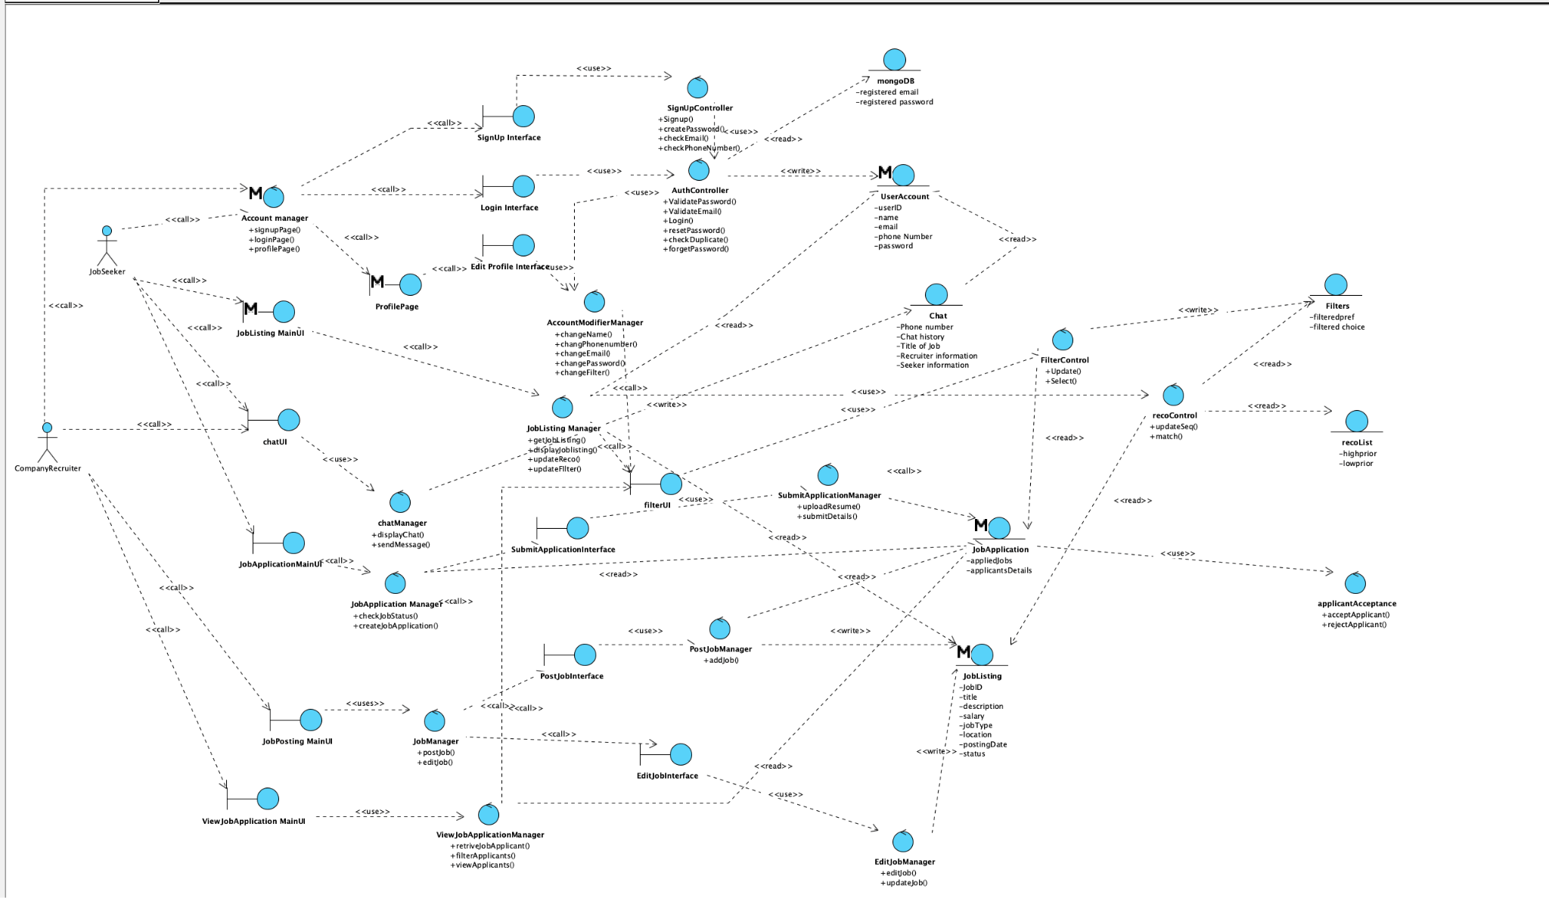

# 

# 

**Sequence Diagrams**

Sequence Diagram for Logging In:

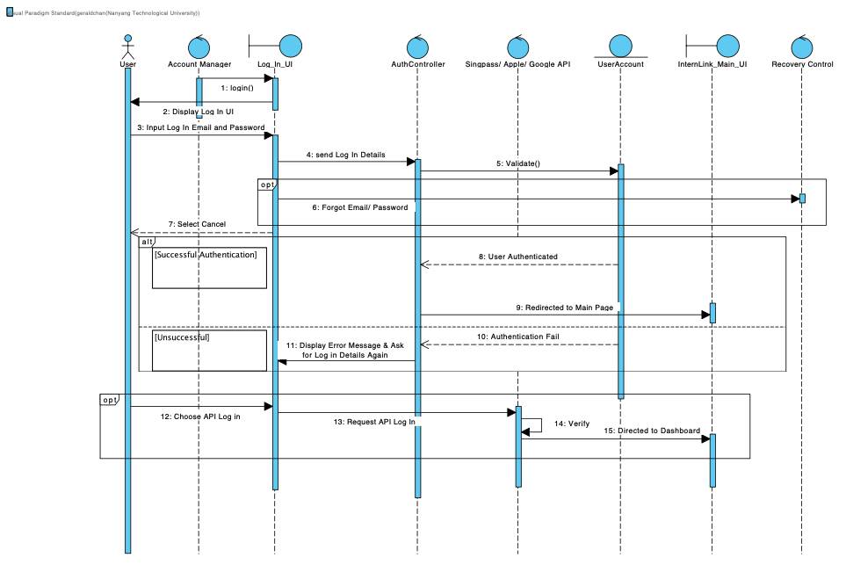

Sequence Diagram for Signing Up:

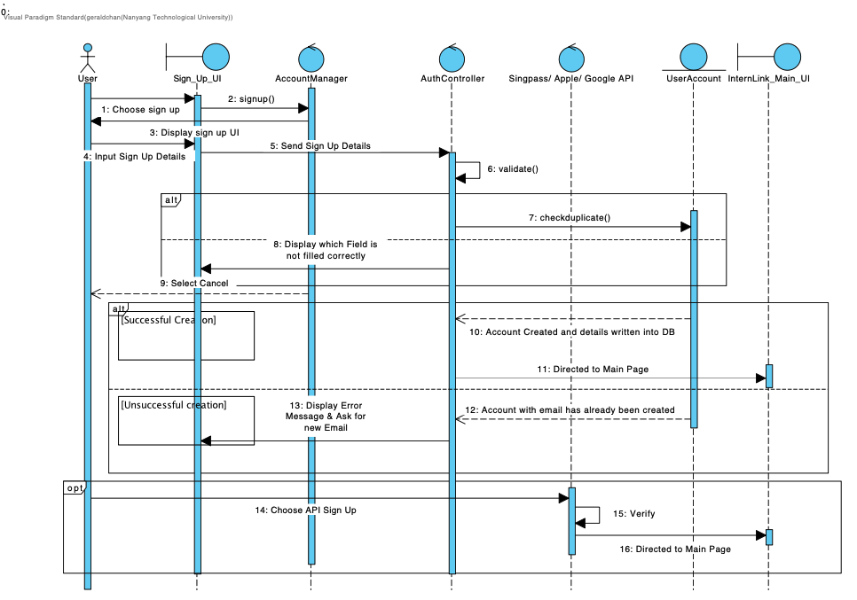

Sequence Diagram for Editting Profile: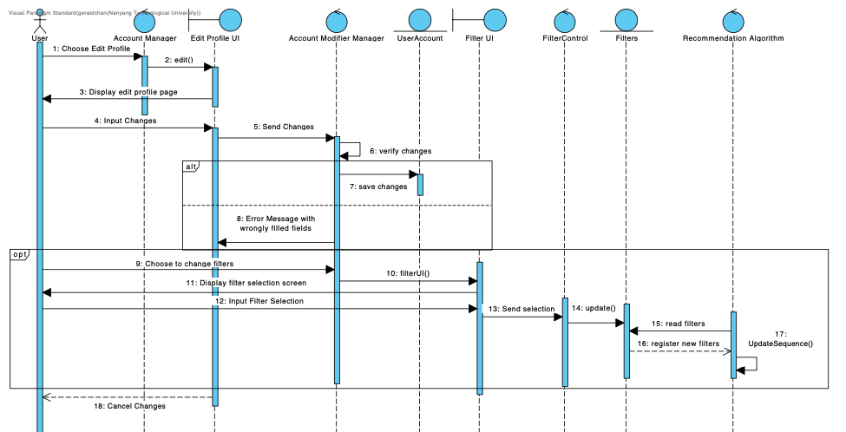

Sequence Diagram for Job Seeker’s Job Application: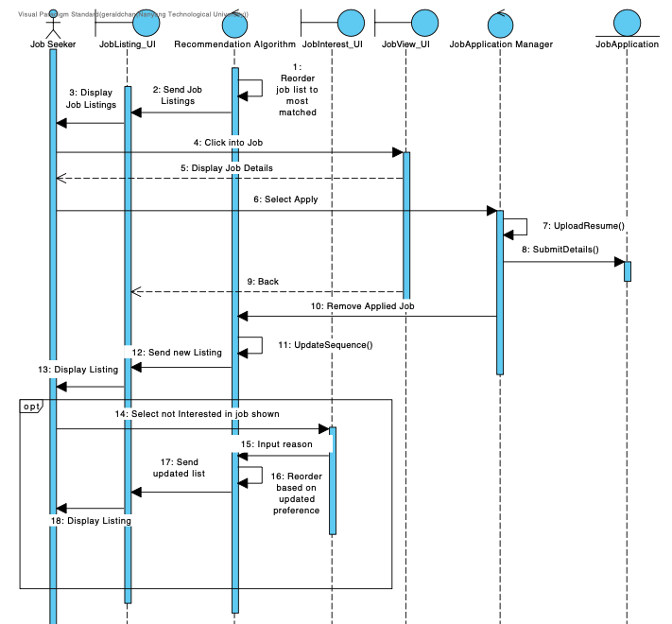

Sequence Diagram for Employer’s Job Posting & Editting: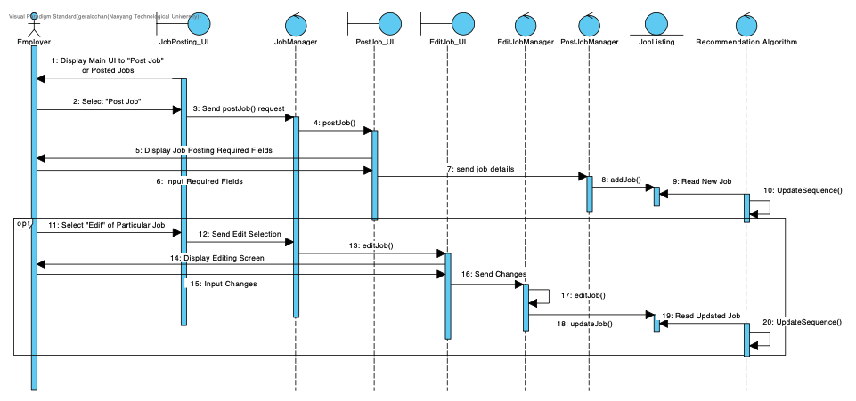

Sequence Diagram for Chat Messaging: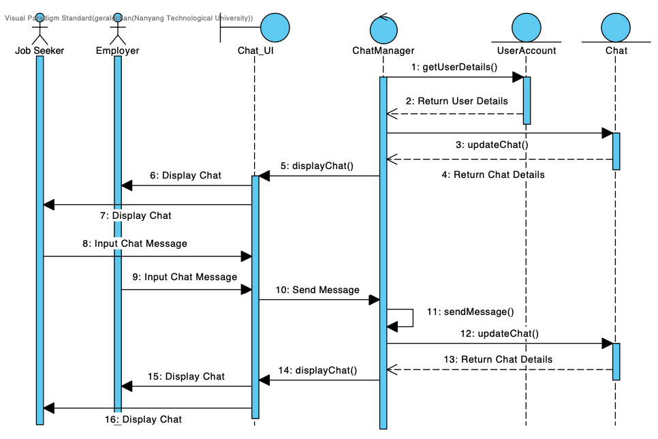

**Initial Dialog Map**

